Smart: flexible parasol design

Shade with character: the Smart
Frauenfeld, November 2023 – Modern and ingenious: the new Smart from Glatz embodies simplicity, elegance and intelligent engineering in one. It is flexible enough to adapt to the position of the sun, and robust enough to withstand the elements. With this design, the Swiss parasol manufacturer once again demonstrates its expertise in uniting aesthetics and functionality.

A modern compact parasol with a minimalist design – meet the new Smart from Glatz. A high-quality parasol – nothing more, nothing less. Here, first-class materials meet Swiss precision without any bells and whistles. Appearing as if it were floating in mid-air, the flat parasol roof in combination with the simply designed ball and socket joints means that the Smart does exactly what a good parasol should: provide reliable protection while looking stylish. The perfect choice even for challenging environments.
Comfort at the turn of a handle
One rotation, one sliding motion to change the world. The ergonomically slim runner makes it easy to open and close the parasol roof. An intimate canopy for an afternoon nap, or a shady oasis for an al-fresco brainstorming session: you decide. Thanks to the tilter, the Smart can be tilted up to 32 degrees on both sides. The Smart is also flexible in terms of its size, as the parasol comes in a variety of round, rectangular and square formats. And the height can be adjusted by up to 50 centimetres – all thanks to a simple rotary knob positioned at a user-friendly height. Whether it’s for your patio, café or small balcony: there is always a Smart to suit your needs.

Colour? Yes, but used sensibly
The Smart’s frame comes in the muted tones of matt white and anthracite. But when it comes to the canopy fabric, the world of colour is your oyster: you have over 65 shades to choose from. This means that the Smart is not only eye-catching but also chameleon-like, blending in subtly and tastefully in any environment.

Characters with spaces: 1,998

Adaptable shade design and sun protection. The stylish way to enjoy protection from the sun.

The mastery is in the detail: a robust tilter meets elegant parasol design. | 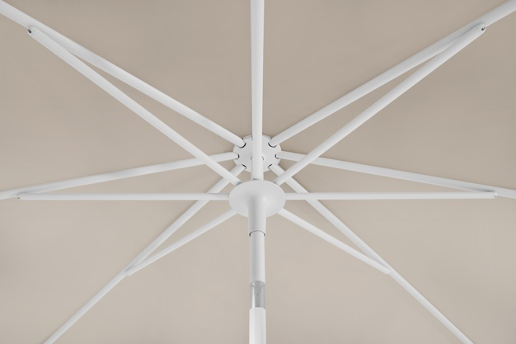
Clear lines, clear colours: matt, white, light, anthracite – the right colour to suit every taste.  Link to images:  https://go.wetransfer.com/t-wOEqbyr3Rh | 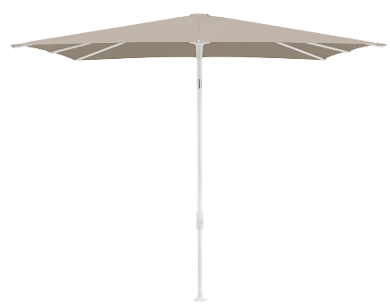  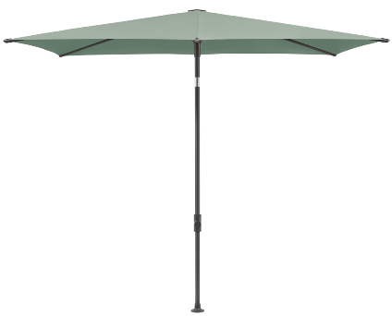  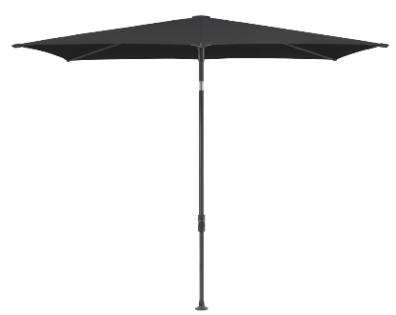  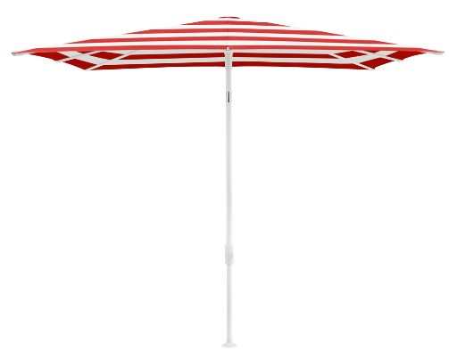

About Glatz
Based in Frauenfeld, Switzerland, Glatz AG combines over 125 years of traditional craftsmanship with innovative design. The company is a market leader in Europe, offering sun-protection solutions for private and commercial use. With an impressively wide range of combination options and deeply rooted quality standards, Glatz stands for more than just shade: it represents a piece of the good life, directly from Switzerland.

