Glatz presents the design innovation Twist
A floating design and ergonomic operation
Frauenfeld, October 2022 – An extra flat parasol roof, stepless tilting, 360° rotation, ergonomic operation – with the new Twist centre-pole parasol, parasol professional Glatz once again shows all its skills. With its innovative design and user-friendly functionality, this new parasol has what it takes to become a true design icon.
At first glance, the roof of the new parasol really does seem to float. This is ensured by the wide, flat ribs with ball and socket joints and the flexible rib ends, which ensure that the high-quality canopy remains well tensioned at all times.
What makes the Twist the perfect companion on the balcony and terrace are its refined functionality and carefully thought-out ergonomics. Glatz has developed new technical solutions for the Twist for which patents have already been filed. All the controls, such as opening, tilting and swivelling, are located at waist height and are easy to use, making the parasol ideal for those who struggle with overhead controls or who simply lack strength. Twist is opened and closed using a crank which can be angled when in use. It then returns to a vertical position automatically. As a result, the parasol pole always looks perfectly tidy. The parasol can be tilted steplessly up to 32° and rotated 360° by means of a rotating mechanism. It is also easy to attach using a clamping lever, providing shade in every position. To cut a good figure on low-height balconies or covered loggias, the Twist has an optional pole that can be adjusted in height up to 25 centimetres.
Innovative design with invisible technology
Glatz has also paid attention to the appearance of the other elements: the pole with a soft, octagonal profile is attached to the inner support tube with a snap-on fastener that conceals the tube. Glatz is the first in the sector to use this design for garden parasols. The connection between the base and the pole is covered with an elegant protective cap. The tilting mechanism is integrated into the design of the pole, creating the impression that all the controls are coordinated seamlessly. The aluminium parasol pole is available with either a matt white or anthracite powder coating with plastic elements in the same colour.
Characters with spaces: 2,269
The new centre-pole parasol Twist from Glatz impresses with its innovative design and clever operating functions. | 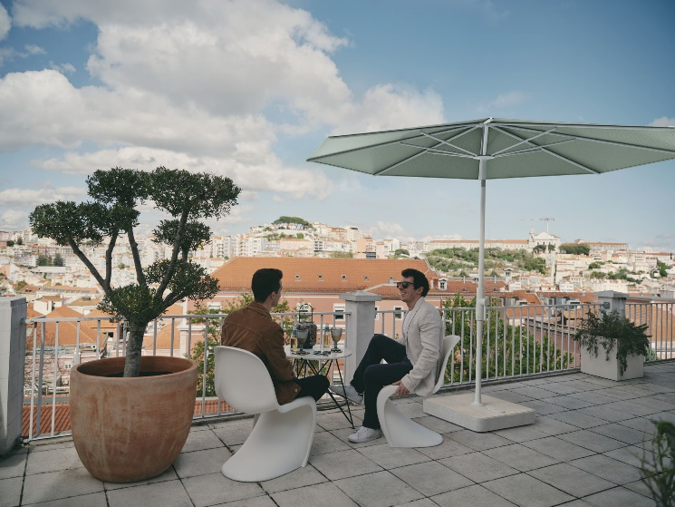
The flat parasol roof rests on wide, flat ribs with ball and socket joints. | 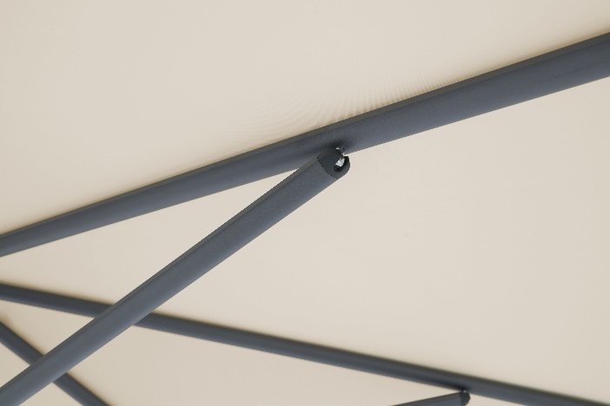
The parasol can be opened, closed and tilted comfortably at waist level with the patent-pending crank and rotary knob | 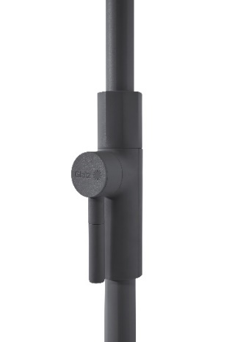
Twist with a matt-white pole. | 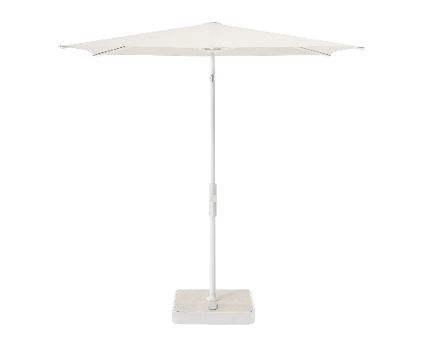

About GLATZ
Based in Frauenfeld, Switzerland, GLATZ AG is one of Europe’s leading parasol manufacturers. The company produces parasols for residential as well as commercial use. The manufacturer sells its range of high-quality parasols via authorised specialist dealers. It fields more than 20,000 possible combinations through to customised solutions, primarily in the giant parasol sector. For contract customers, the manufacturer also sells directly. The family-owned company can look back on more than 125 years of history and has extensive expertise. Internationally registered functional patents for well-designed user comfort, optimal shading, and sustainable all-weather suitability stand for the high quality of the different parasol types. 60 per cent of all products are Swiss made and produced in Frauenfeld. The remaining 40 per cent are of Swiss design and come from the company’s own development department.

