Glatz presents a new fabric collection
Parasol canopies in 70 elegant colours for that special lighting mood
Frauenfeld, November 2022 – The Swiss sun protection expert Glatz has launched a completely new colour collection for its canopies. In collaboration with colour experts and trend scouts from a design studio, a total of 70 elegant shades were compiled that harmonise with the current colour trends for outdoor furniture. The large selection now offers buyers of parasols even more options for the perfect, individual colour design on their balcony and terrace.
Modern outdoor areas have long since become outdoor living rooms, where the taste and style of the living spaces are continued with matching furniture and decor, creating a feel-good ambience of their own. The parasols from Glatz complete the harmonious design. They combine ergonomic function and modern design with high-quality, long-lasting and robust fabrics and sustainable UV protection.
In the new colour collection, pastel, soft tones as well as stronger, colour-intensive tones ensure a pleasant lighting mood and atmospheric moments under the parasol roof. The demand for the selection of fabrics: They should be effective over a large surface, but also exude a certain sophistication in pattern and detail. They are divided into the three fabric qualities 5, 4 and 2 according to material, degree of water repellency, robustness and colour fading. Whereby the highest quality guarantees the best lightfastness and thus the longest lasting colour intensity, the best robustness and water repellency. The higher the fabric quality, the firmer and thicker the fabric. But there is one thing that all high-quality Glatz canopies have in common – regardless of the fabric quality: the maximum possible UV protection of more than 98 per cent, which corresponds to sun protection factor 50 for a sunscreen.
Characters with spaces: 1,769
More info on the creation of the new colour collection in the latest video on YouTube:
Creation of the new fabric collection: https://youtu.be/dcxlt1MJFFo

New Glatz colour collection “Morninglight” with pastel shades. | 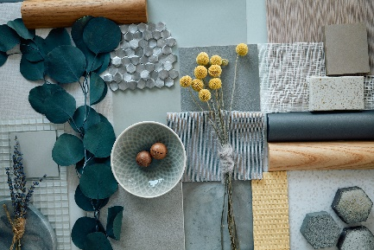
New Glatz colour collection “Sunset Glow” with colour-intensive tones. | 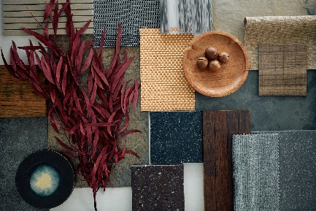
Colour fan of the two new colour collections | 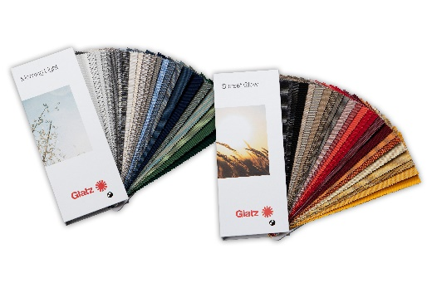

About GLATZ
Based in Frauenfeld, Switzerland, GLATZ AG is one of Europe’s leading parasol manufacturers. The company produces parasols for residential as well as commercial use. The manufacturer sells its range of high-quality parasols via authorised specialist dealers. It fields more than 20,000 possible combinations through to customised solutions, primarily in the giant parasol sector. For contract customers, the manufacturer also sells directly. The family-owned company can look back on more than 125 years of history and has extensive expertise. Internationally registered functional patents for well-designed user comfort, optimal shading, and sustainable all-weather suitability stand for the high quality of the different parasol types. 60 per cent of all products are “Swiss Made” and are produced in Frauenfeld, while the remaining 40 per cent are “Swiss Design” and come from the in-house development department.

